CS 255 System Design Document

UML Diagrams

UML Use Case Diagram

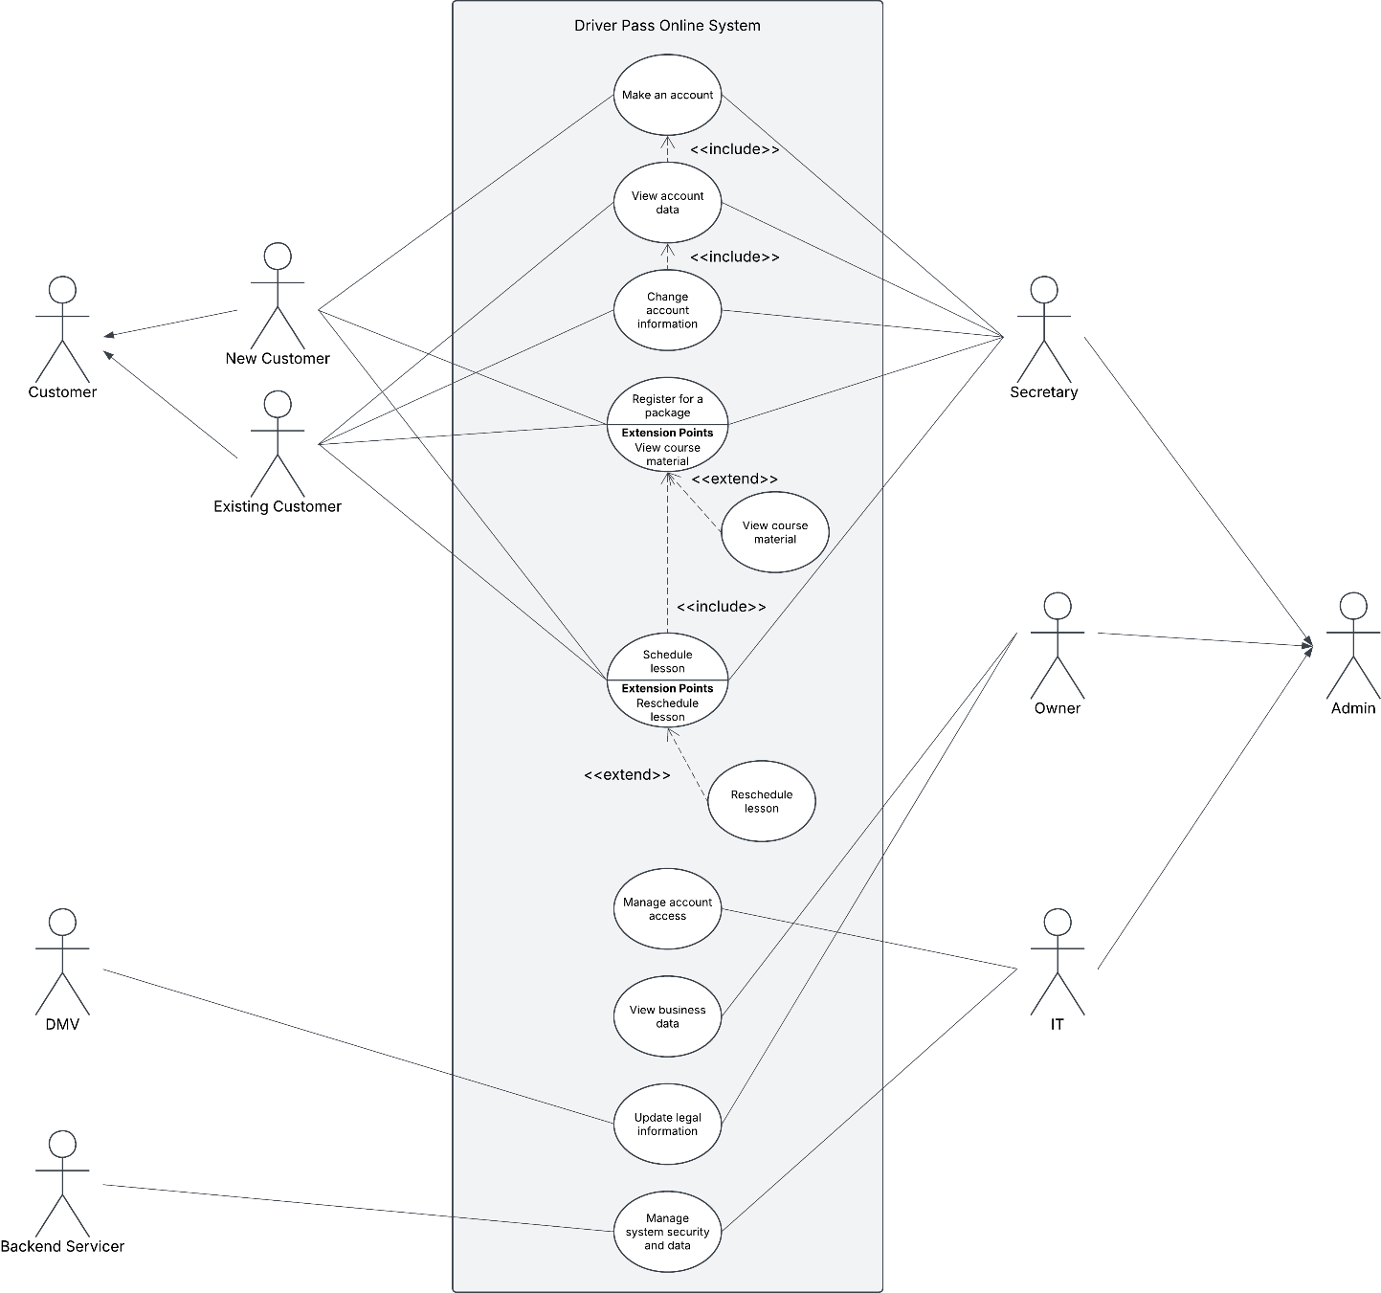

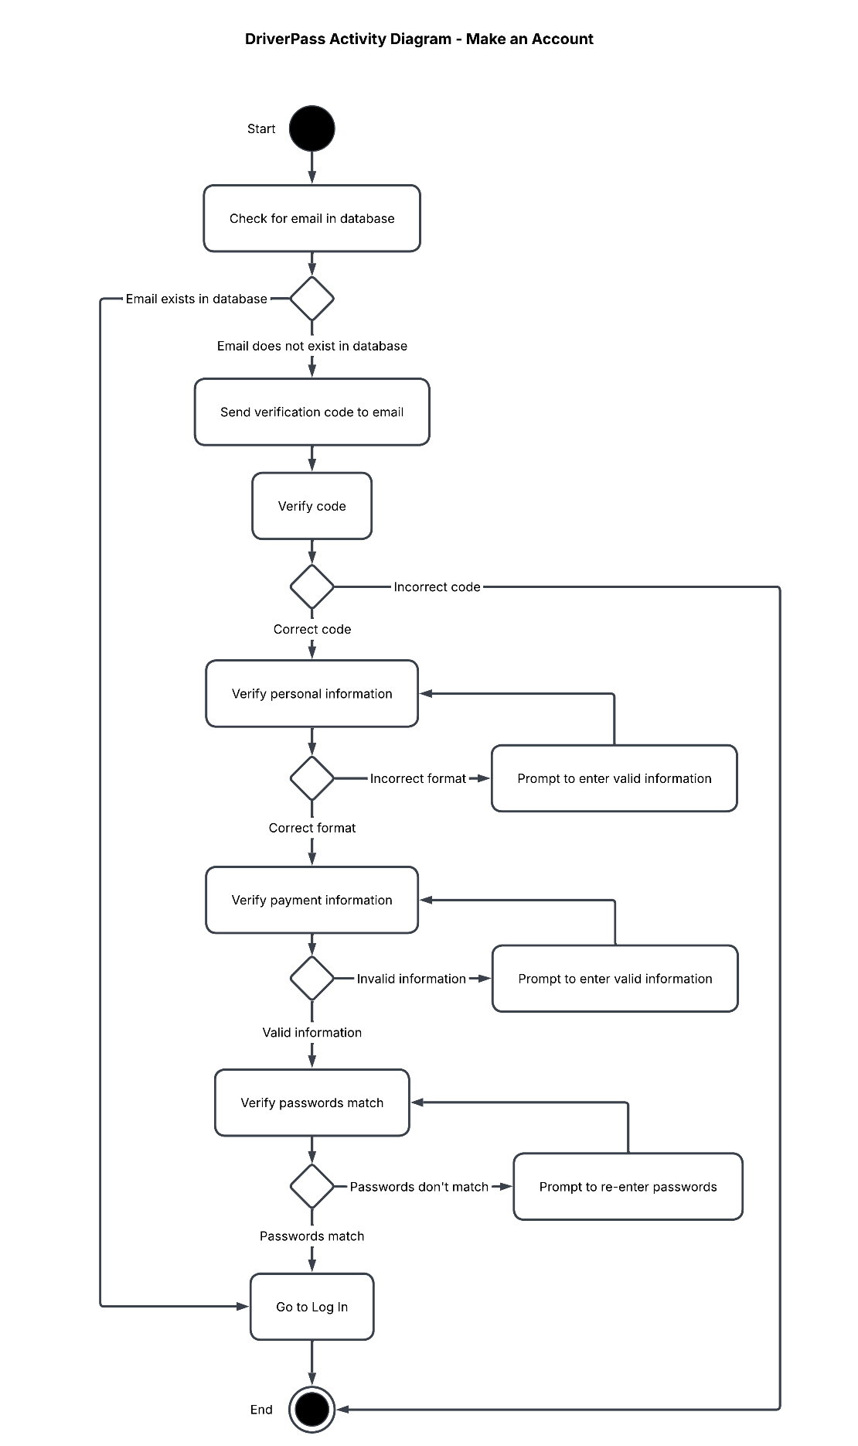
UML Activity Diagrams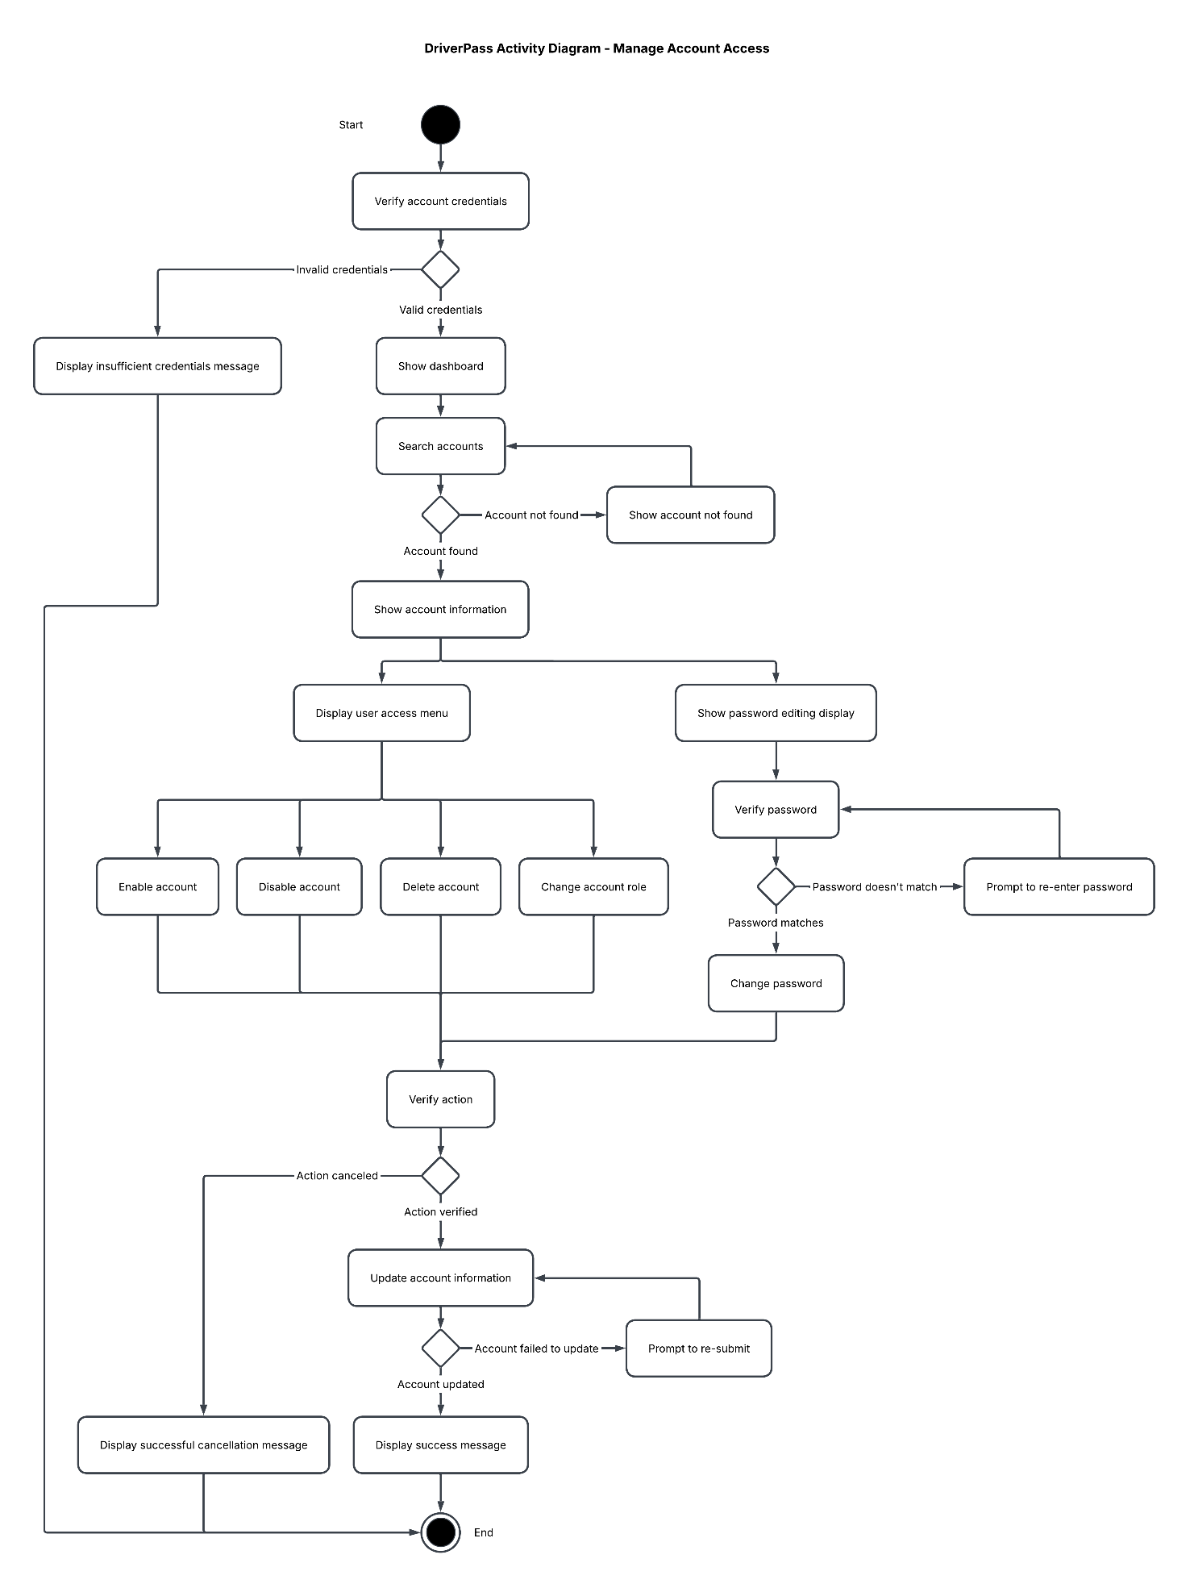

UML Sequence Diagram
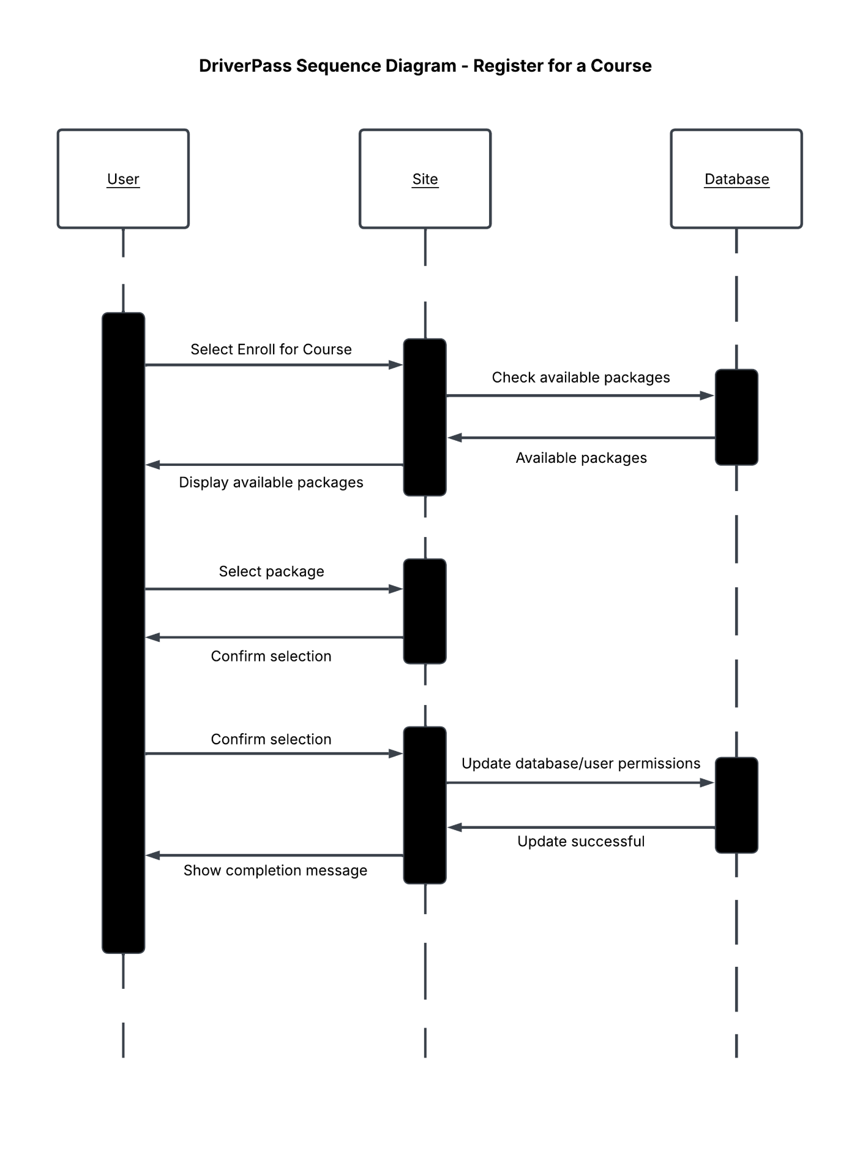

UML Class Diagram
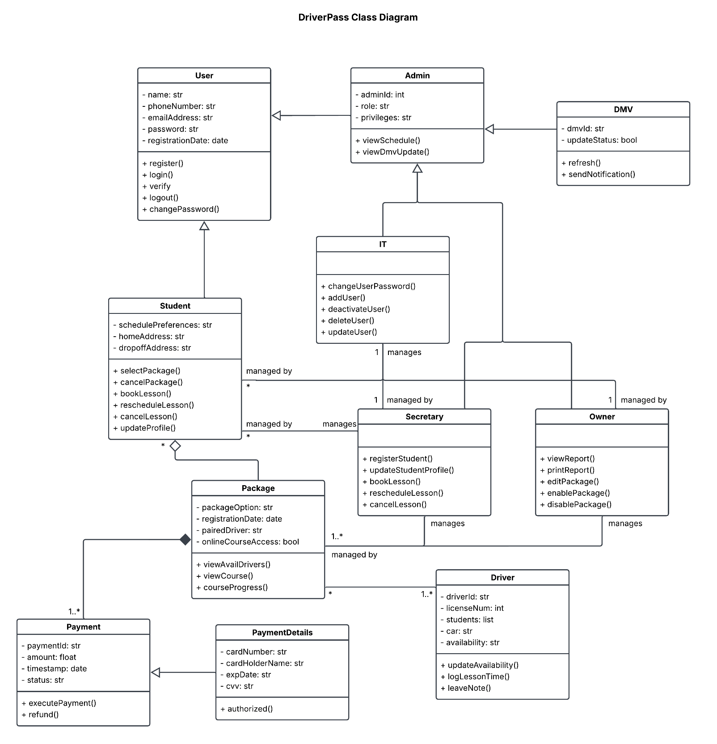

Technical Requirements

- System UI shall be responsive, allowing seamless use across desktop to mobile browsers.
- System must be accessible across all operating systems (OS) (Microsoft Windows, macOS, Linux, iOS, Android, ex..)
- A cloud-native Relational Database (RDBMS) shall be used, such as PostgreSQL, deployed via a cloud service to maintain data integrity, store package data, and maintain compliance with regulations in the state DriverPass operates in.
- Implement input field validation utilizing regular expressions on the front end (JavaScript) and back end (server-side validation).
- User credentials shall be stored securely using BCrypt for password hashing and salted encryption.
- Shall use an email service, such as SendGrid, to send verification emails containing a time-limited activation link.
- Implement secure login using OAuth 2.0 alongside JSON Web Tokens (JWT) to manage sessions.
- System shall not store raw cardholder data, implementing tokenization to maintain compliance with PCI-DSS levels one through four.
- Utilize HTTPS for secure communication between the client and server.
- Use client-side filtering via JavaScript frameworks to dynamically update package and lesson results.
- Shall fetch filter options from backend dynamically via available data.
- Implement transactional database operations using PostgreSQL.
- Use a message queue, such as RabbitMQ, to process package and lesson confirmations and send transactional emails asynchronously.

